SQL Queries (Balaji Food Sales Analysis)

1.Data Cleaning
- Removing Null columns which I won’t be using in the data analysis process
code:

ALTER TABLE balaji_sales
DROP COLUMN column11,column12,column13;
-before
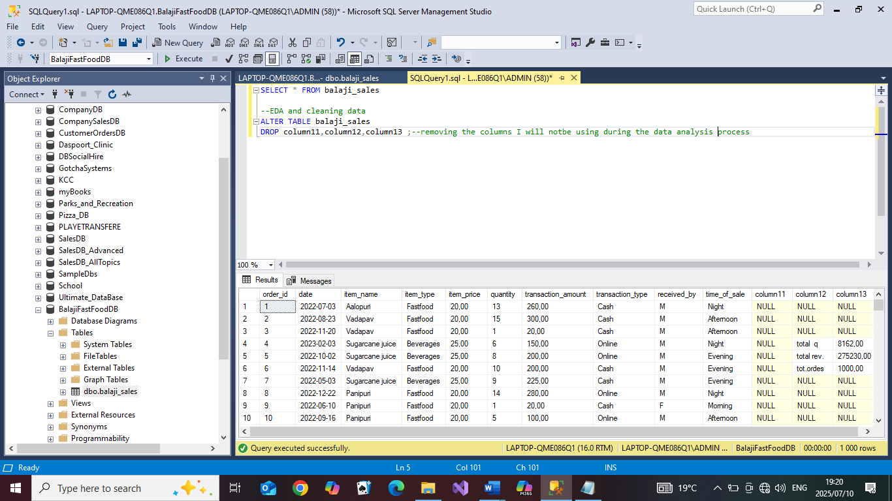
-results
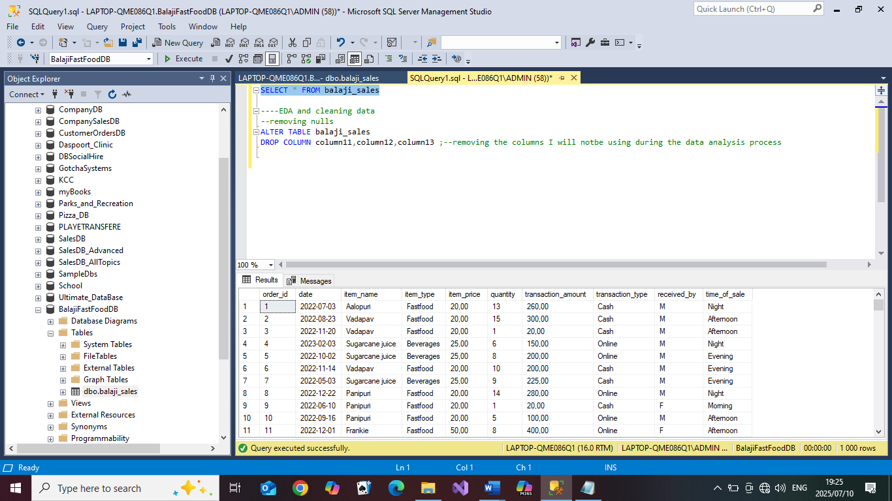

- Checking if other rows have Nulls in all columns
code:
SELECT * FROM balaji_sales WHERE order_id IS NULL
SELECT * FROM balaji_sales WHERE [date] IS NULL
SELECT * FROM balaji_sales WHERE item_name IS NULL
SELECT * FROM balaji_sales WHERE item_type IS NULL
SELECT * FROM balaji_sales WHERE quantity IS NULL
SELECT * FROM balaji_sales WHERE transaction_amount IS NULL
SELECT * FROM balaji_sales WHERE transaction_type IS NULL
SELECT * FROM balaji_sales WHERE received_by IS NULL
SELECT * FROM balaji_sales WHERE time_of_sale IS NULL
-results:
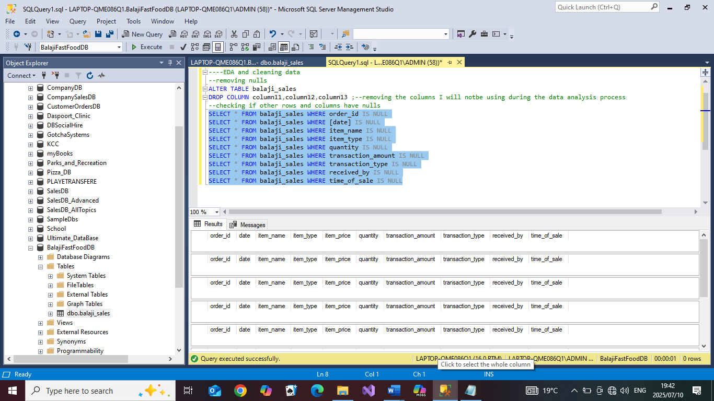
- Extracting and adding Day and Month Columns for trend analysis
Code:
ALTER TABLE balaji_sales
ADD DayOfTheWeek as DATENAME(DW,[date]),
MonthOfSale as DATENAME(MONTH,[date]);

SELECT * FROM balaji_sales

-results:
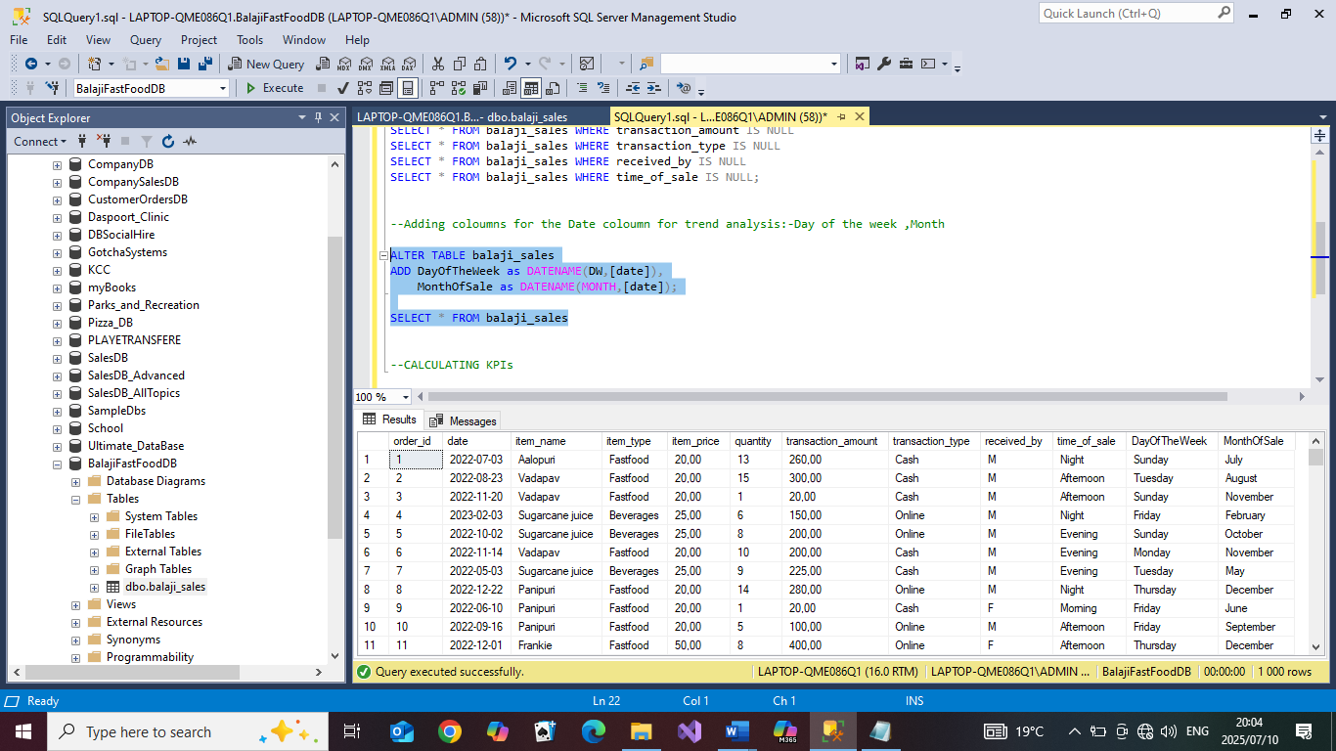

- Standardizing text in the gender column, changing ‘M’ to Male and ‘F’ to Female for more clarity
Code:
UPDATE balaji_sales
SET received_by='Male'
WHERE received_by='M'
UPDATE balaji_sales
SET received_by='Female'
WHERE received_by='F'

-results:
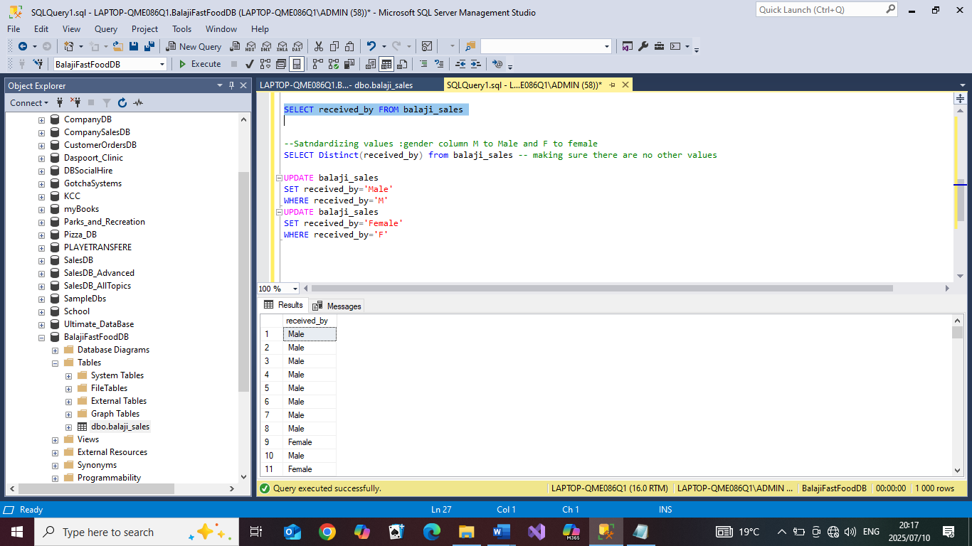

- Checking for duplicated values
code:

With dupls as (
SELECT order_id,date,item_name ,ROW_NUMBER() OVER(PARTITION BY order_id,date,item_name ORDER BY order_id) as RowNum FROM balaji_sales
)

SELECT * FROM dupls WHERE RowNum>1

-results:
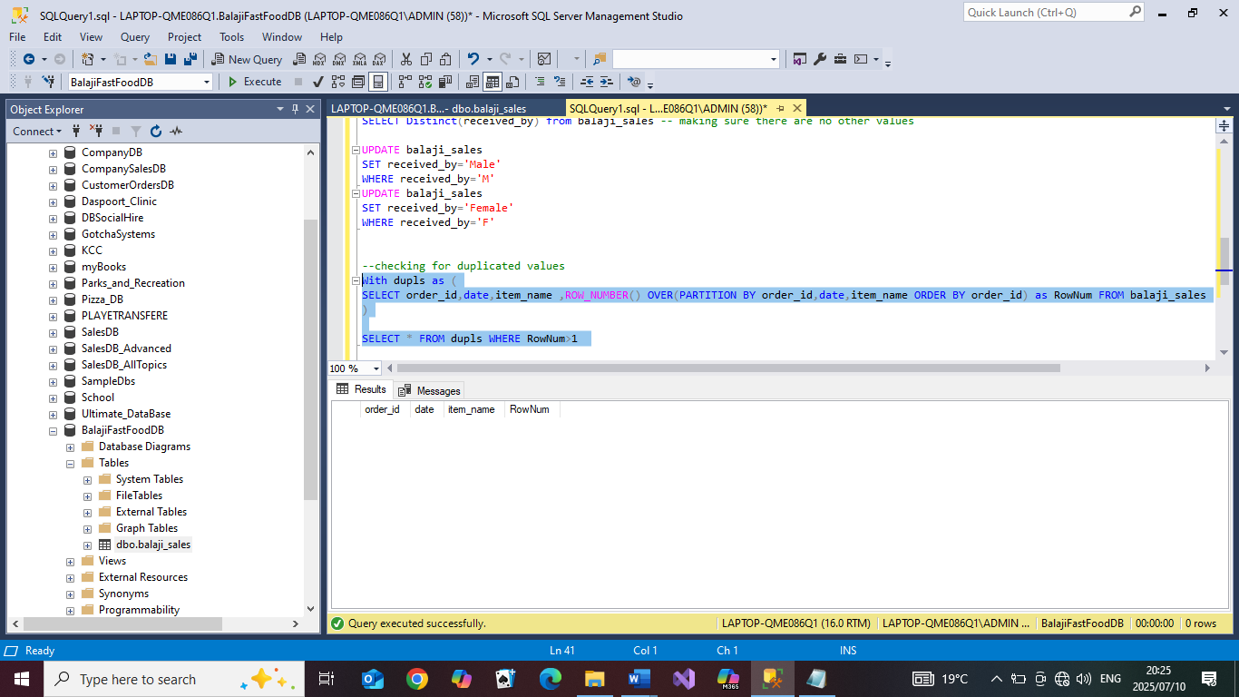

2.Calculating KPIs
- Total Revenue For the Year
Code:
SELECT Round(SUM(transaction_amount),2) as [Total Revenue] FROM balaji_sales

-results:

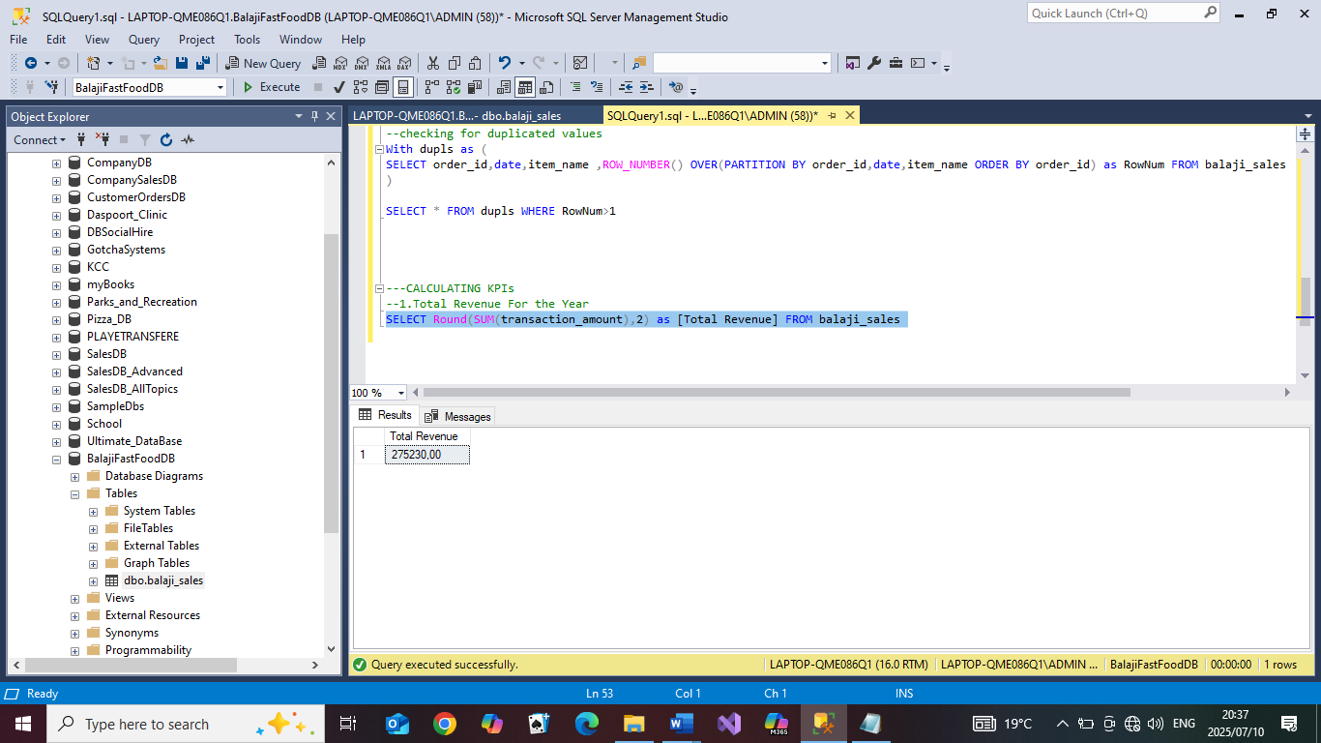

- Total revenue on each item type
Code:
SELECT Round(SUM(transaction_amount),2) as [Total Revenue],item_type FROM balaji_sales GROUP BY item_type
-Results:
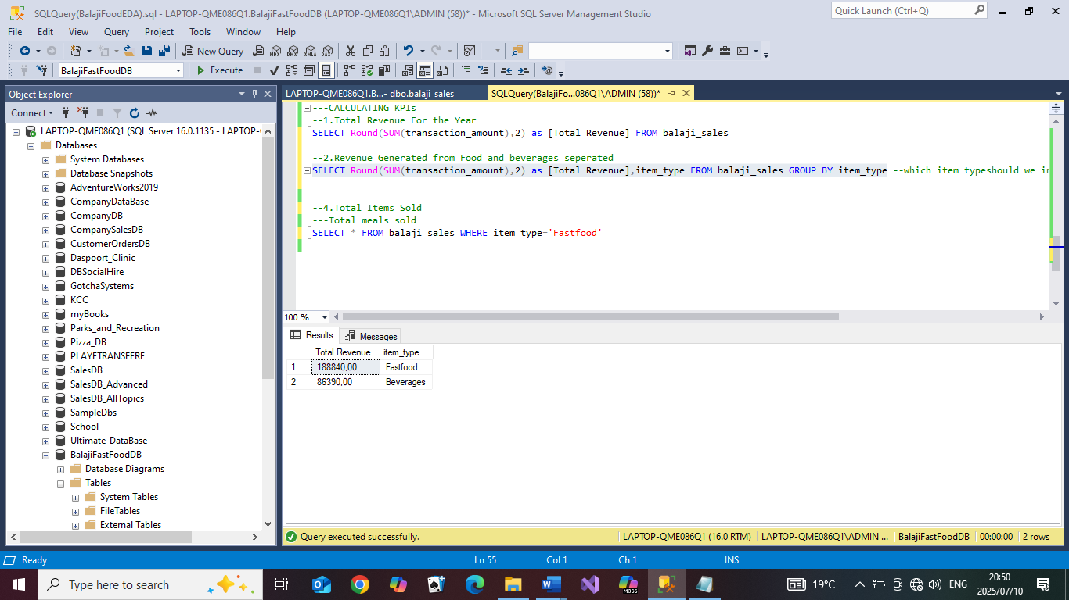

- Total number of orders made
code:
SELECT COUNT(order_id) as [Total Orders] FROM balaji_sales

Results:
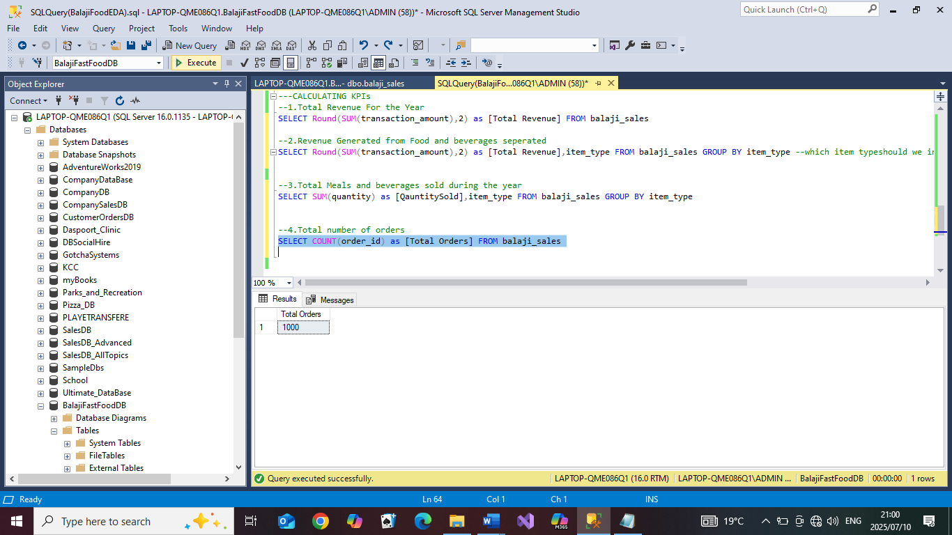

- Total number of orders on each item type
code:
SELECT COUNT(order_id) as [Total Orders],item_type
FROM balaji_sales GROUP BY item_type
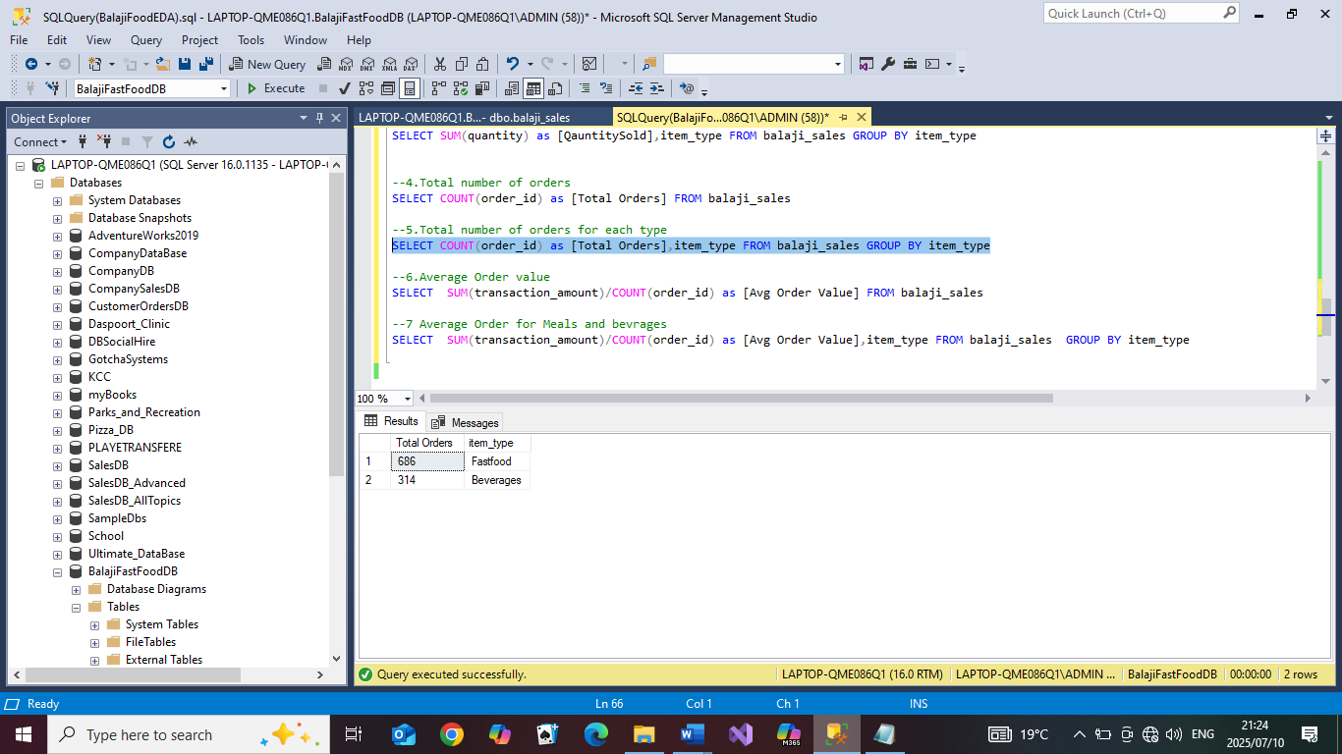

- Average order value
Code:
SELECT SUM(transaction_amount)/COUNT(order_id) as [Avg Order Value]
FROM balaji_sales

Results:

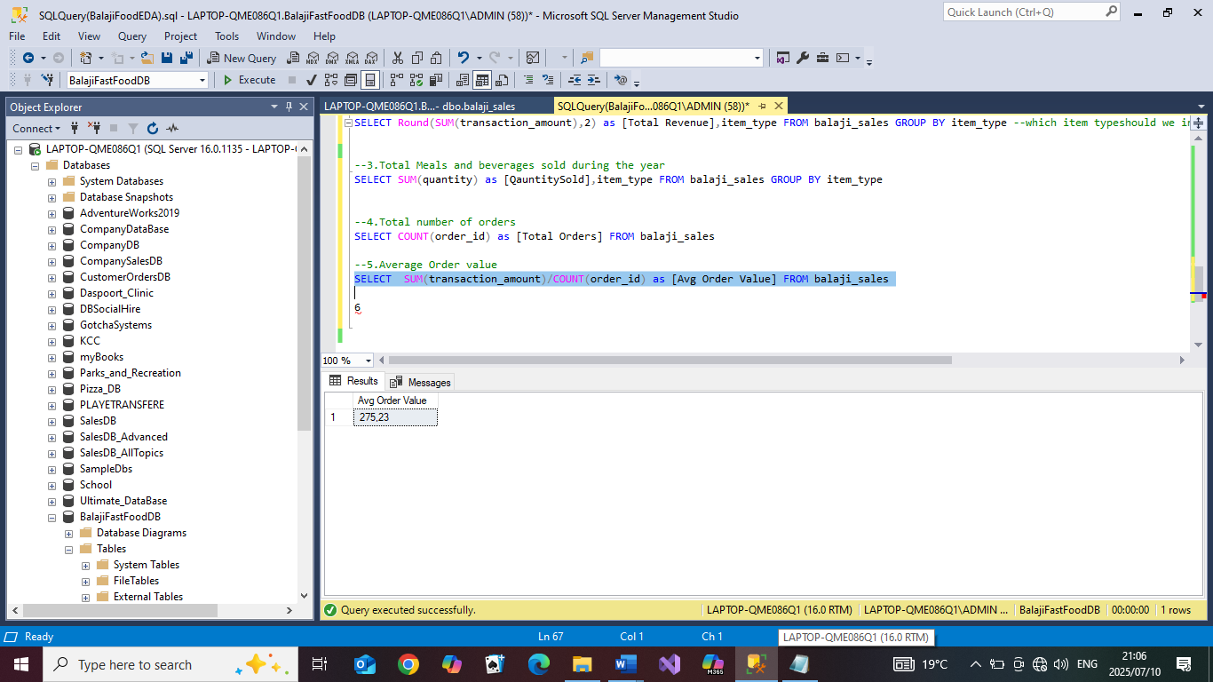

- Average order value of each item type for the year
Code:
SELECT SUM(transaction_amount)/COUNT(order_id) as [Avg Order Value],item_type FROM balaji_sales GROUP BY item_type

Results:
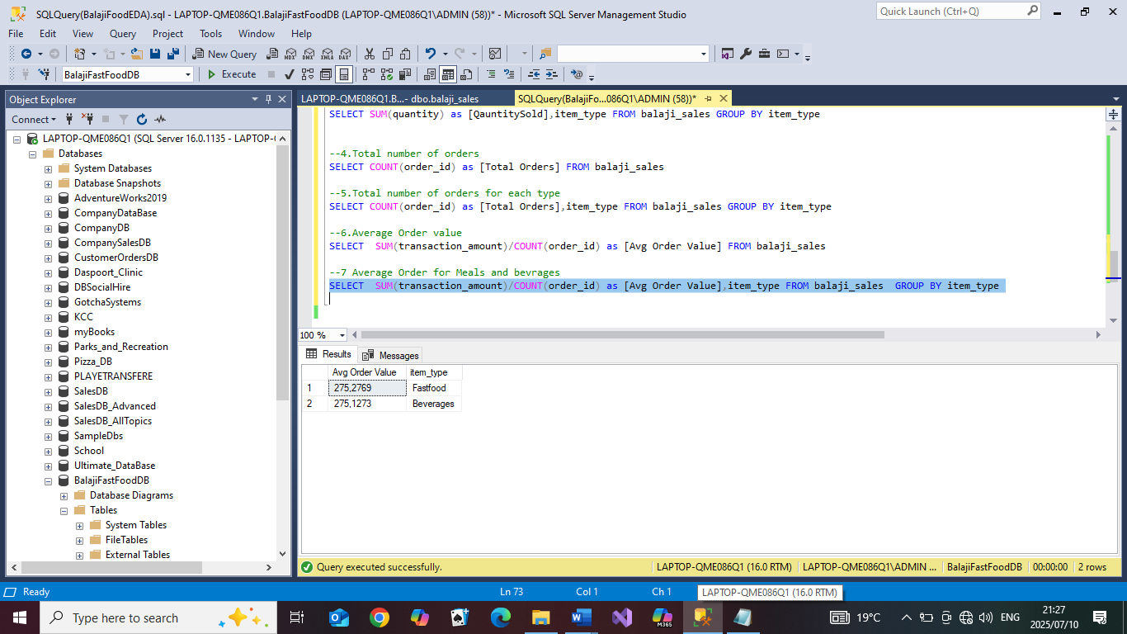

3.ANALYSIS
- Trend analysis
-Monthly Trends: Looking at revenue for each month
code:
SELECT SUM(transaction_amount) AS [Sales],YEAR([date]) as
[Year],MonthOfSale
FROM balaji_sales GROUP BY YEAR([date]),MonthOfSale Order by
YEAR([date])
results:
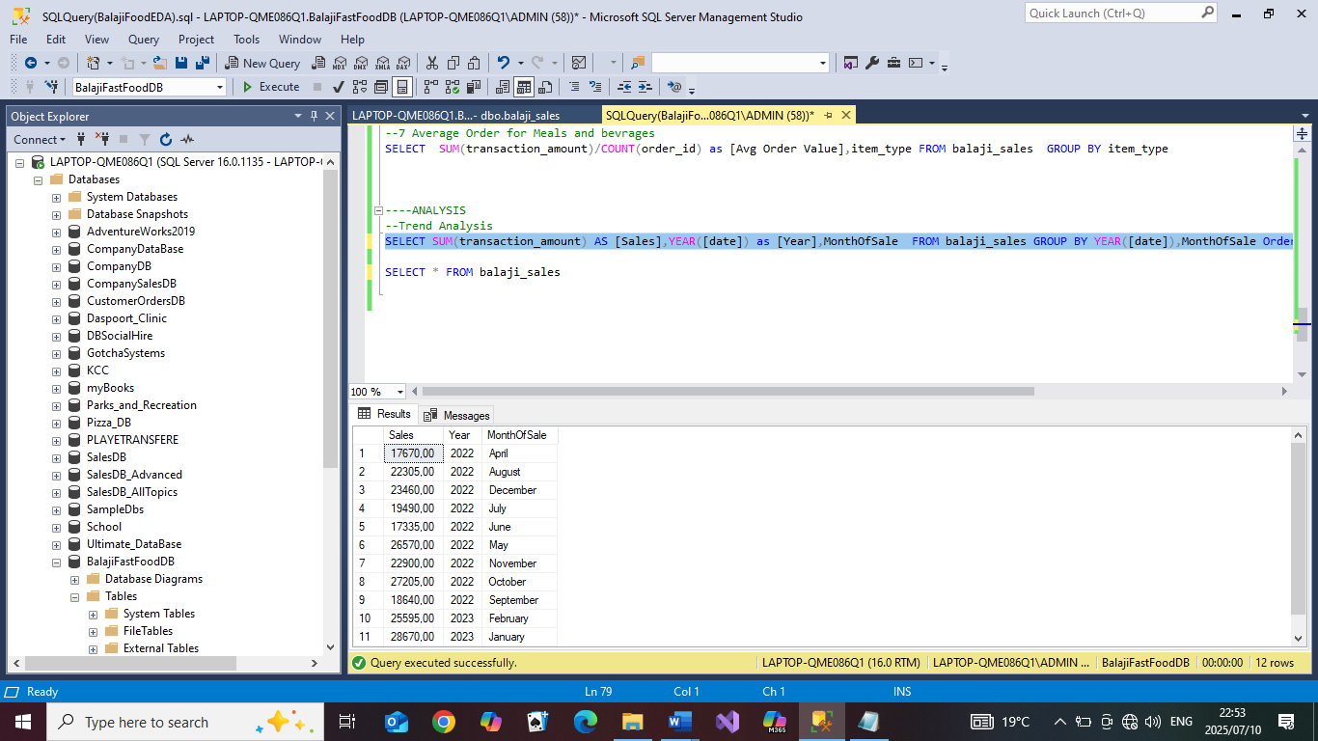

-Looking at the month with the most sales
code:

SELECT SUM(transaction_amount) AS [Sales],YEAR([date]) as [Year],MonthOfSale
FROM balaji_sales GROUP BY YEAR([date]),MonthOfSale
Order by SUM(transaction_amount) DESC

Results:
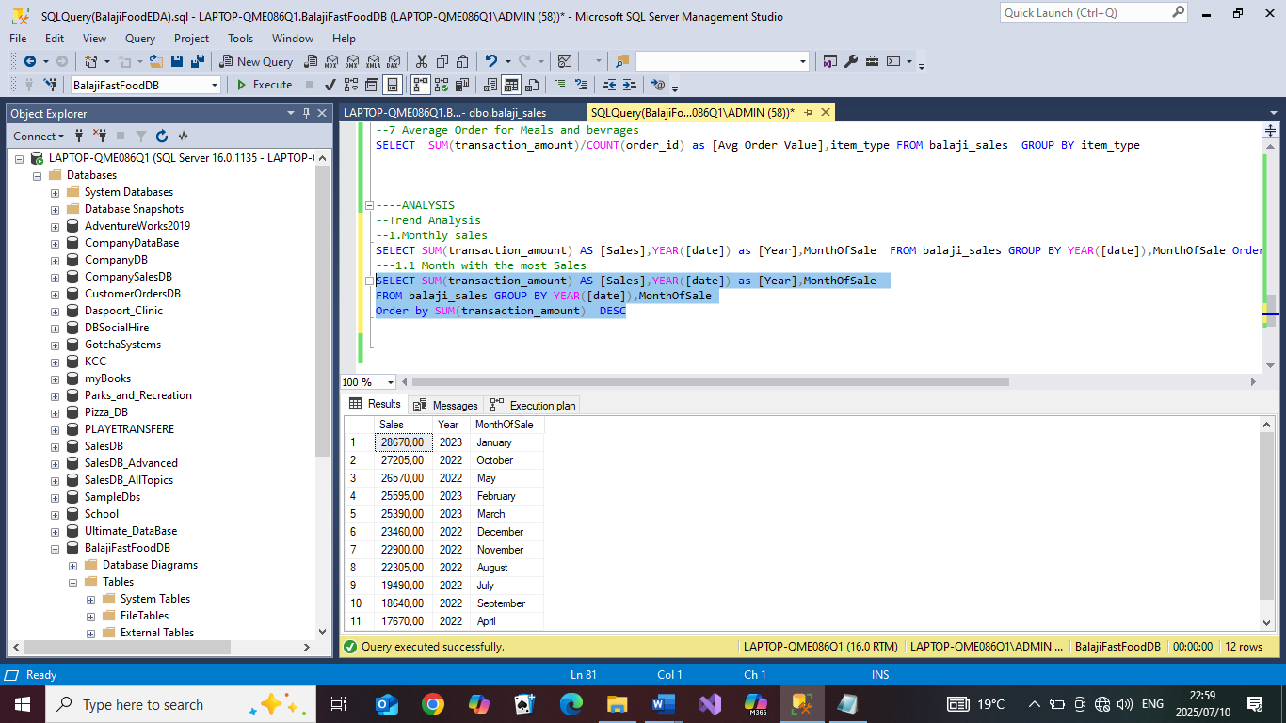

-Daily trend: Looking at the revenue generated over the year for each day and seeing which day generated the most amount of sales
Code:
SELECT SUM(transaction_amount) AS [Sales],DayOfTheWeek
FROM balaji_sales
GROUP BY DayOfTheWeek
ORDER BY SUM(transaction_amount) DESC

Results:
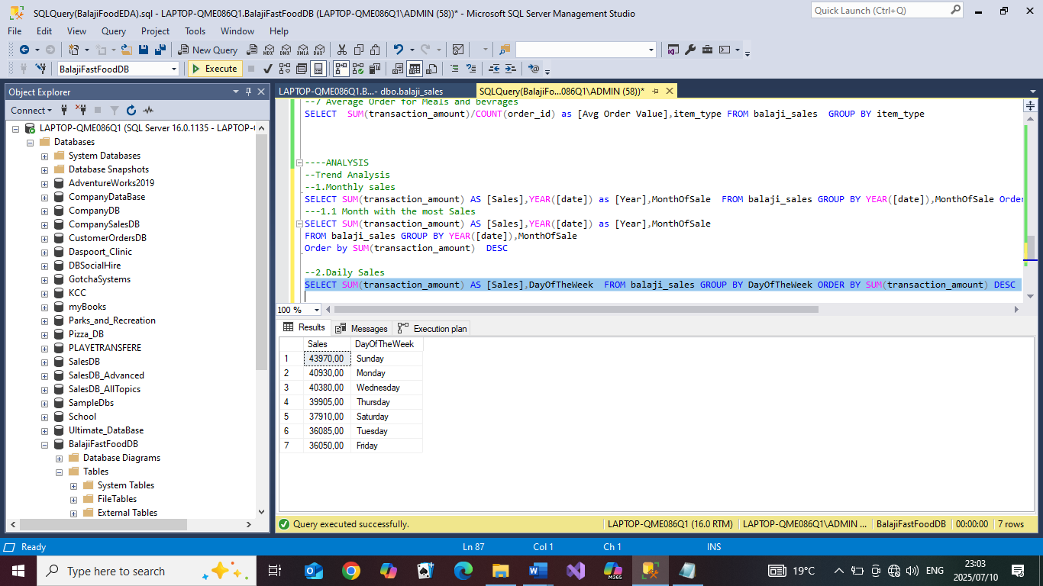

-Time of sale: Time during the day in which sales are being made
Code:
SELECT SUM(transaction_amount) AS [Sales],time_of_sale
FROM balaji_sales
GROUP BY time_of_sale
ORDER BY SUM(transaction_amount) DESC

results
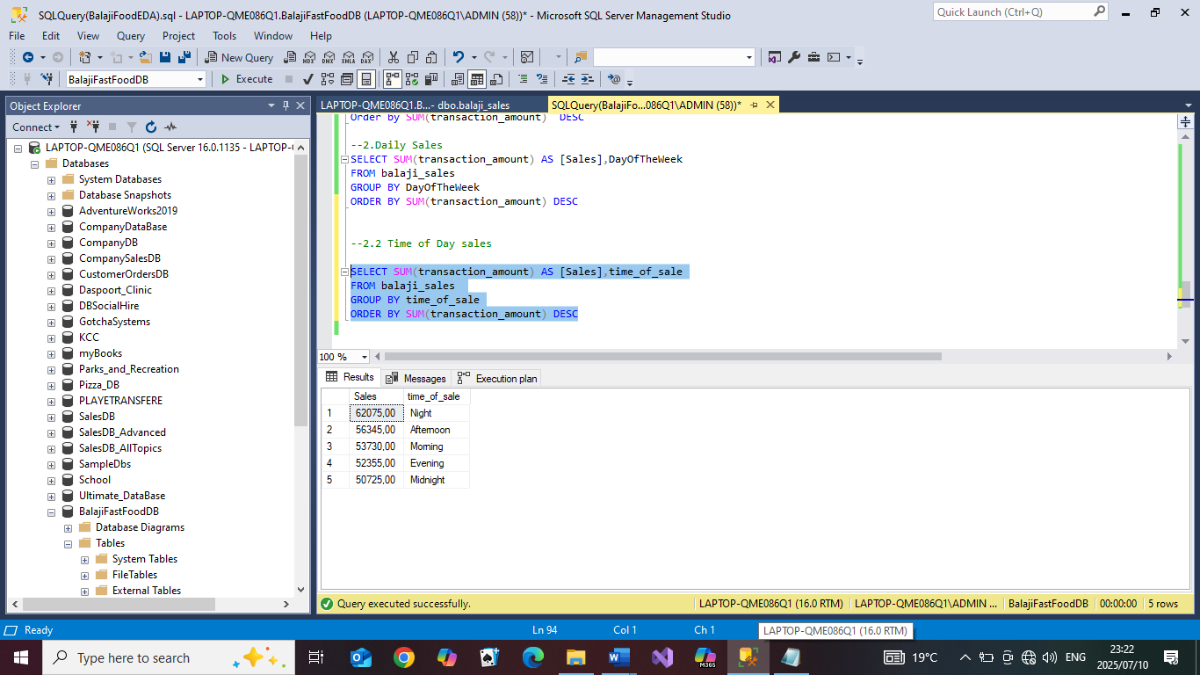

- Analysis: Looking at other factors not time bound that might affect sales
-Gender: Looking at gender and seeing which gender buys more
Code:
SELECT SUM(transaction_amount) AS [Sales],received_by
FROM balaji_sales
GROUP BY received_by
ORDER BY SUM(transaction_amount) DESC
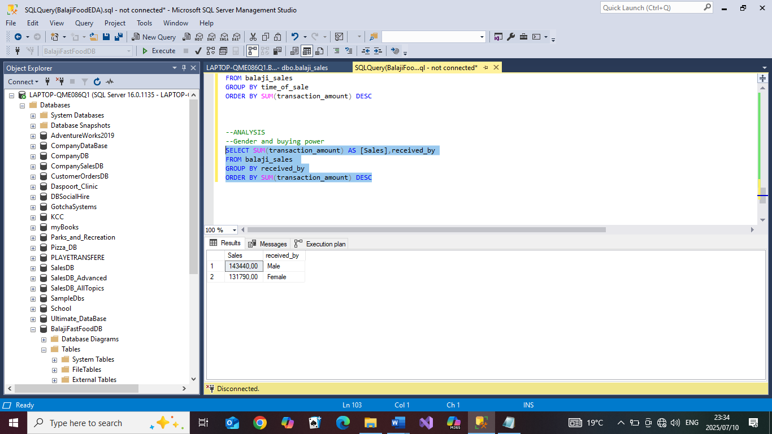

-Transaction type and its’ possible effect on sales
Code
SELECT SUM(transaction_amount) AS [Sales],transaction_type
FROM balaji_sales
GROUP BY transaction_type
ORDER BY SUM(transaction_amount) DESC

Results:
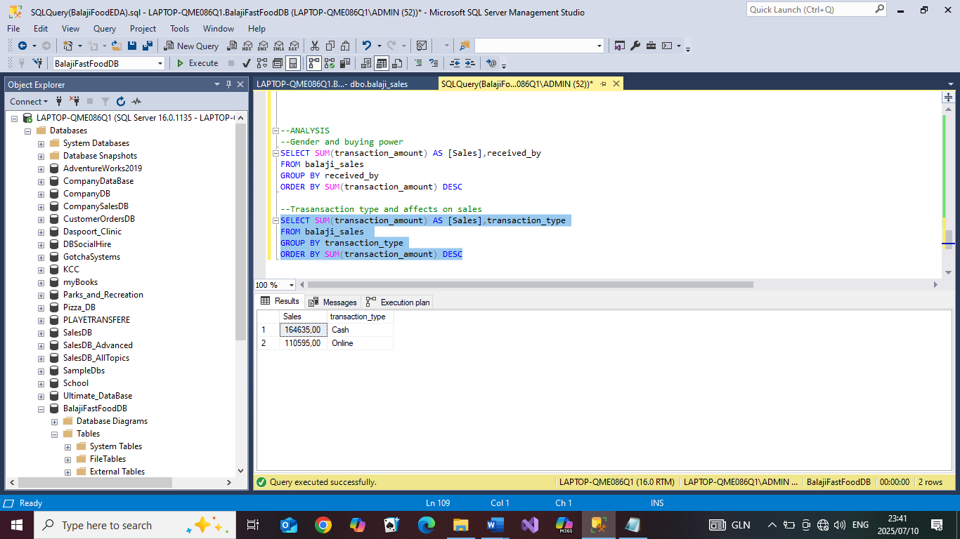

-Foods and drink types, and how they generated sales: Looking the top foods and top
drinks according to sales
Code:
SELECT SUM(transaction_amount) as [Sales],item_name
FROM balaji_sales
WHERE item_type='Fastfood'
GROUP BY item_name
ORDER BY SUM(transaction_amount) DESC

SELECT SUM(transaction_amount) as [Sales],item_name
FROM balaji_sales
WHERE item_type='Beverages'
GROUP BY item_name
ORDER BY SUM(transaction_amount) DESC

Results:
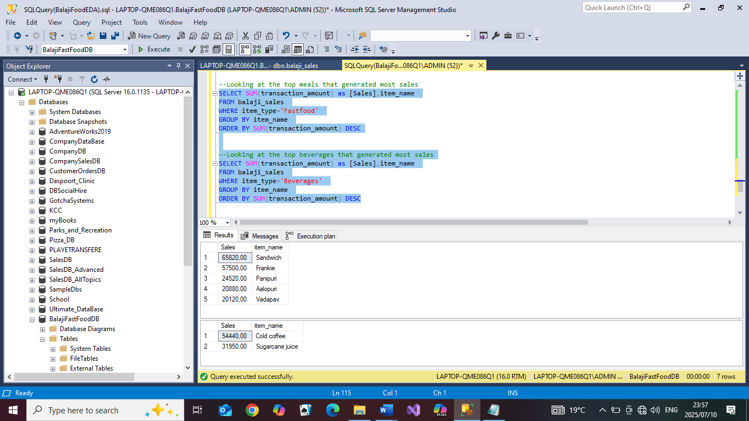

-Looking at the top foods and beverages that were bought the most over the year
Code:
SELECT SUM(quantity) as [Items Sold],item_name
FROM balaji_sales
WHERE item_type='Fastfood'
GROUP BY item_name
ORDER BY SUM(quantity) DESC

SELECT SUM(quantity) as [Items Sold],item_name
FROM balaji_sales
WHERE item_type='Beverages'
GROUP BY item_name
ORDER BY SUM(quantity) DESC

